**Prerequisites**:

Reactjs library

React dom library

Babel (js preprocessor) – to compile next generation js code we write to the code that runs fine in the browser

webpack to import css files into javascript files

BEST PRACTICE:

Use Class based components for state management and functional components for presentation

Definitions:

React Hooks – react functions u can add into any functional components

**Without react:**

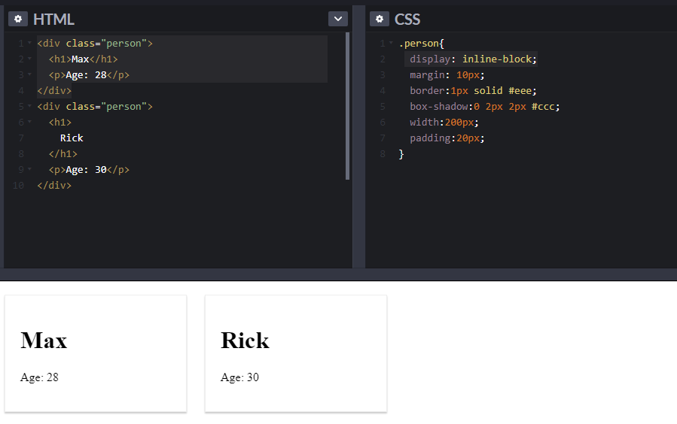

**Writing a react component**: React component is a function

* Function name must start with Uppercase
* Html inside javascript – JSX
* Using document.queryselector(‘#elementid’) to find the element by its id
* Using React to render html to a div. Notice class in HTML is changed to className. Class is a keyword in javascript, so use className instead for the css to apply.

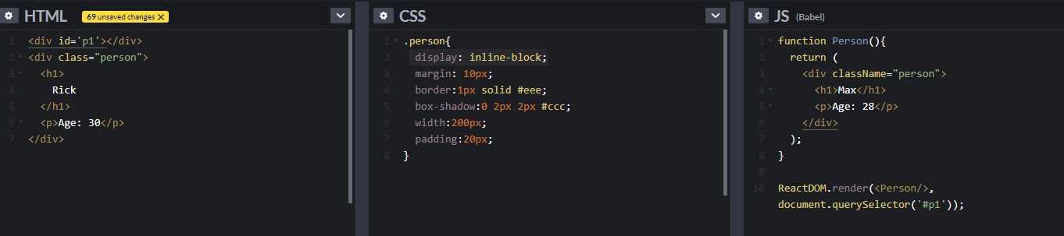

Reusable React Component:

* React allows passing arguments in function, props in the below screen but can be any name.
* Properties can be passed in the render and can be accesses in the component using single curly braces { }

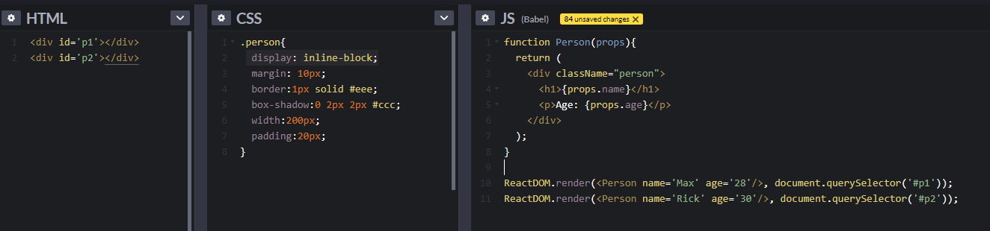

Efficient way of writing multiple renderDOM into one to create single page applications

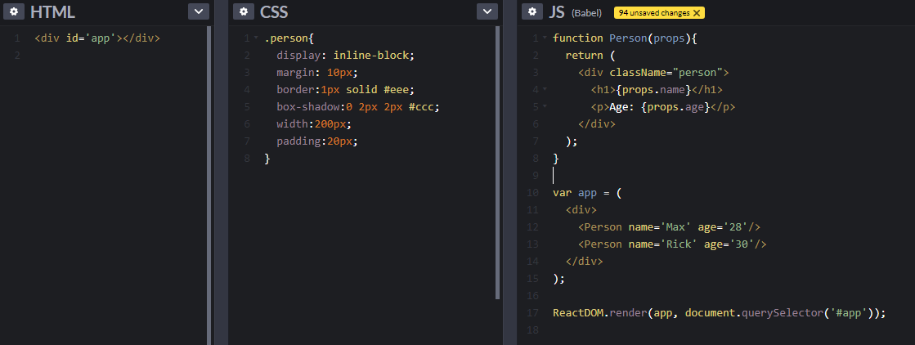

Single page vs multipage applications

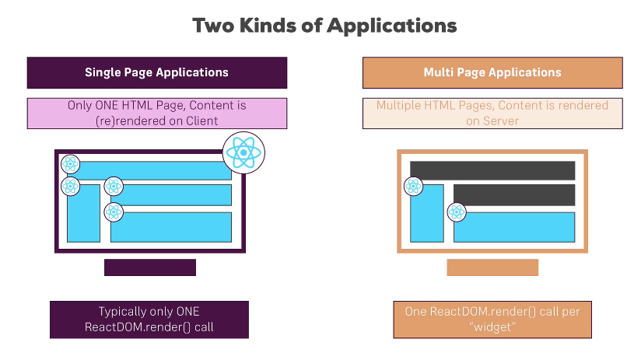

**ES6 JavaScript**

**Arrow Functions**

Regular js function

*Function fun(name){*

*Console.log(name);*

*}*

ES6 Javascript function: solves problem with this keyword

*Const fun=(name)=>{*

*};*

Other form: no need for parenthesis for arguments when only one argument and no need to add return after arrow. Below function will return 4.

*Const multiply= number => number*2*

*Console.log(Multiply(2))*

**Exports and Imports**

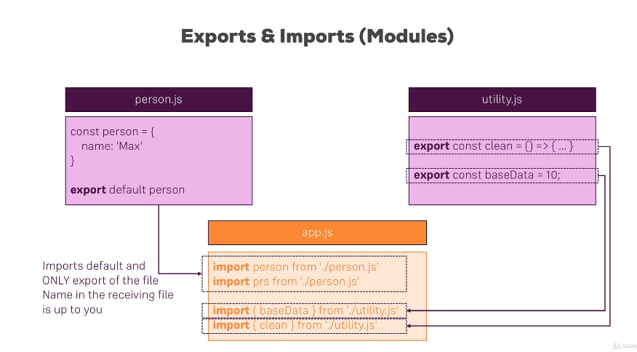

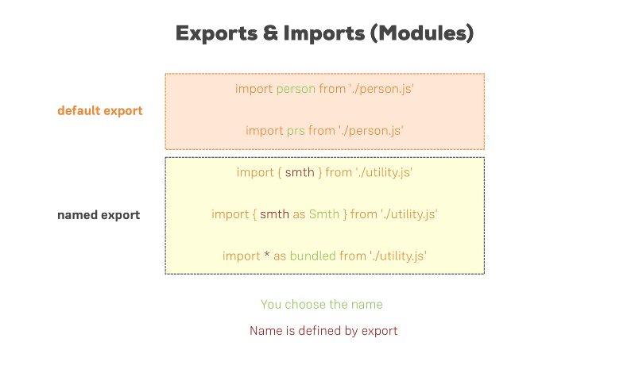

**Classes:** blueprints for objects

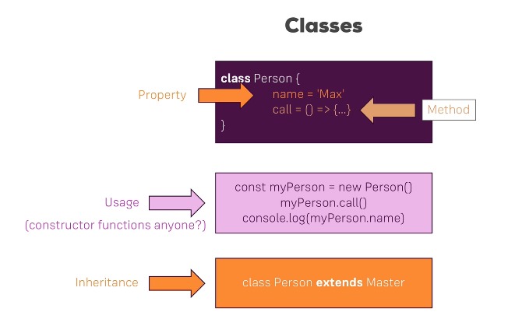

**Class Creation and usage with inheritance**

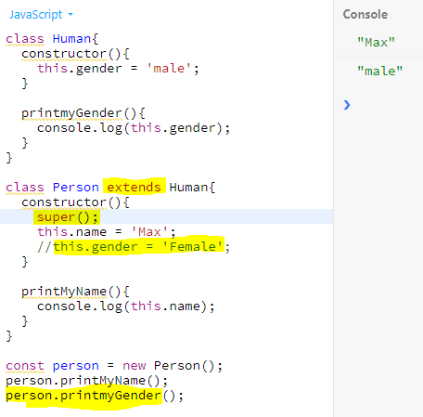

**ES6 VS ES7**

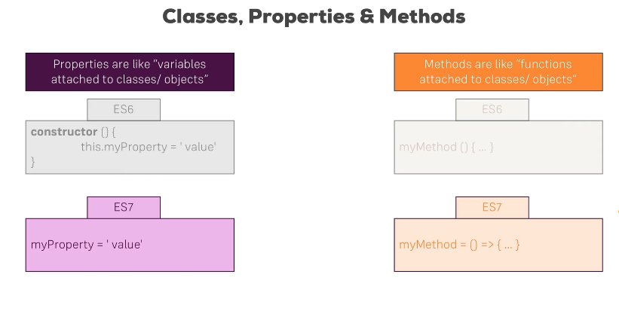

**Same inheritance example using next gen es7, using arrow function and without constructor or super keyword**

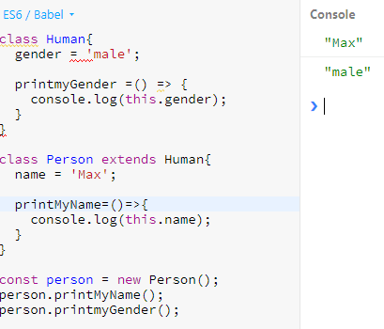

**Spread vs Rest Operator**

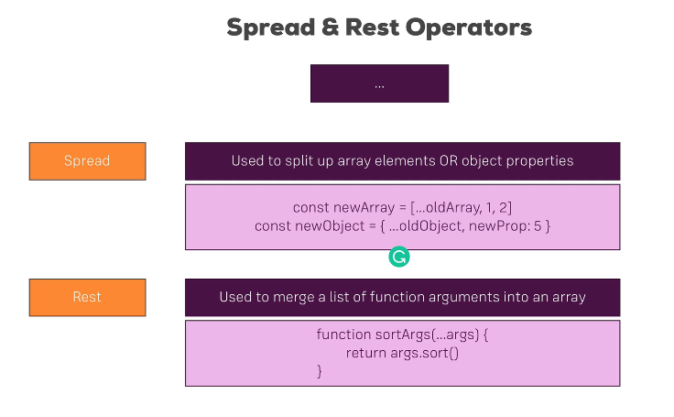

**Example with and without spread, rest operator in arrays, objects and methods**

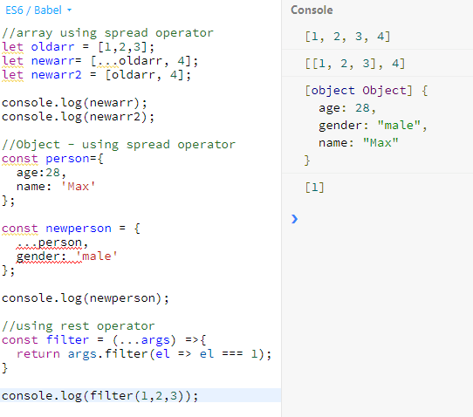

**Array and object destructuring**

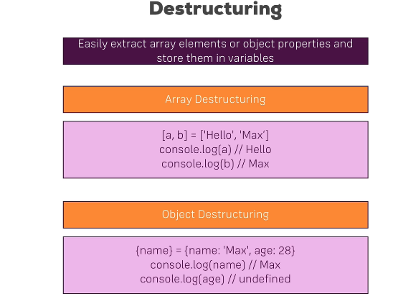

**Objects and Arrays are reference types. USE SPREAD OPERATOR TO ACTUALLY COPY THE OBJECT, Otherwise a pointer is used to write the value**

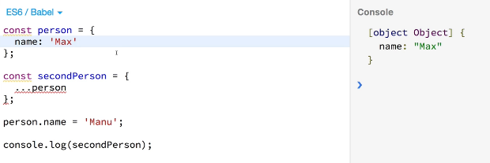

**Array functions example**

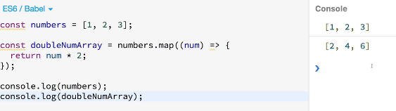

**REACT BASICS**

**Using a Build Workflow**

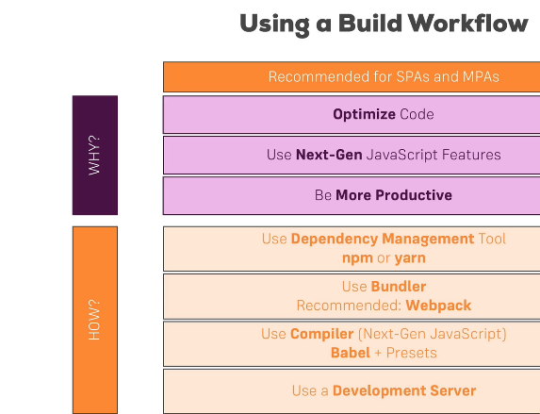

**Create a react app: need to download node.js from nodejs.org to use npm (node package manager)**

[**https://github.com/facebook/create-react-app**](https://github.com/facebook/create-react-app)

**usin cmd/terminal (-g to provide access globally)**

rakesh:desktop madhulikarakesh$ sudo npm install create-react-app –g

Create a new react app names ‘react-complete-guide’

rakesh:react madhulikarakesh$ create-react-app react-complete-guide --scripts-version 1.1.5

render and return are very important to return the html

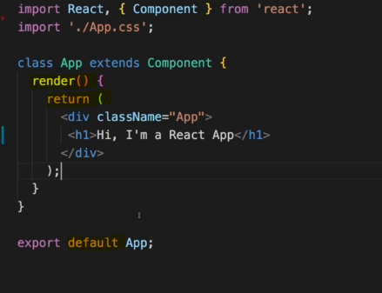

**Use className instead of class in JSX for css.**

**Creating a functional component:**

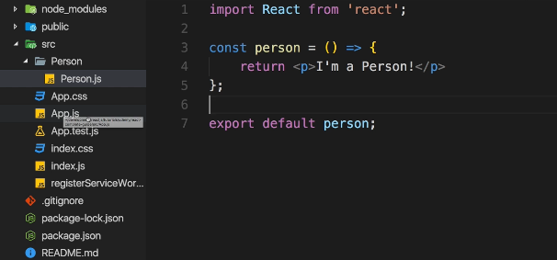

**using in root component, always use Uppercase for component names**

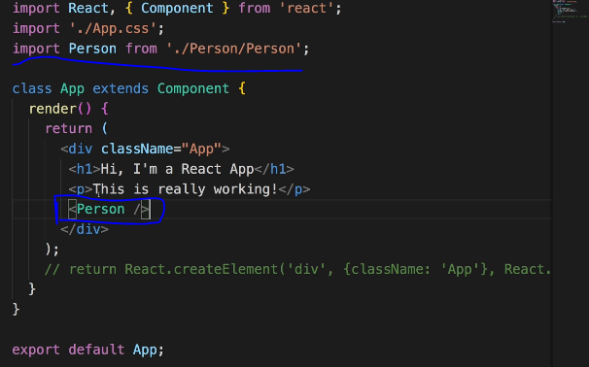

Summary of JSX:

Components are the **core building block of React apps**.

A typical React app therefore could be depicted as a **component tree** - having one root component ("App") and then an potentially infinite amount of nested child components.

Each component needs to return/ render some **JSX** code - it defines which HTML code React should render to the real DOM in the end.

**JSX is NOT HTML** but it looks a lot like it. Differences can be seen when looking closely though (for example className in JSX vs class in "normal HTML"). JSX is just syntactic sugar for JavaScript, allowing you to write HTMLish code instead of nested React.createElement(...) calls.

When creating components, you have the choice between**two different ways:**

1. **Functional components** (also referred to as "presentational", "dumb" or "stateless" components - more about this later in the course) => const cmp = () => { return <div>some JSX</div> } (using ES6 arrow functions as shown here is recommended but optional)
2. **class-based components** (also referred to as "containers", "smart" or "stateful" components) => class Cmp extends Component { render () { return <div>some JSX</div> } }

Use single curly braces to output dynamic content

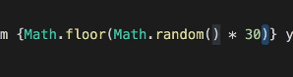

Passing dynamic content as props

In the class:

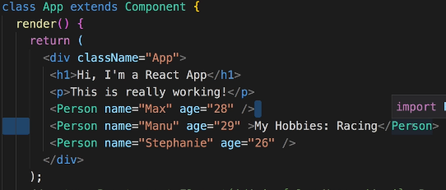

**In the reusable component:**

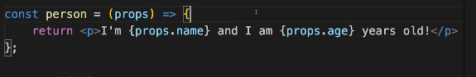

**Using Children prop: ‘children’ refers to any elements within the opening and closing tag of the component. This can be any html text or other react component.**

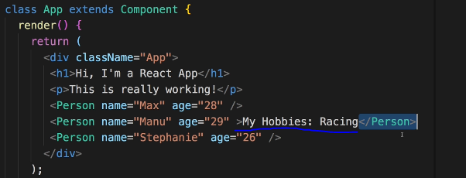

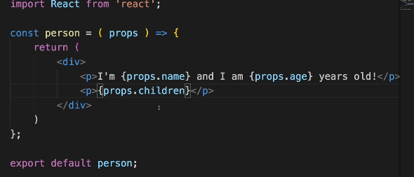

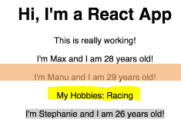

**In components that extends components only – u can create a state property to manage component internal data.**

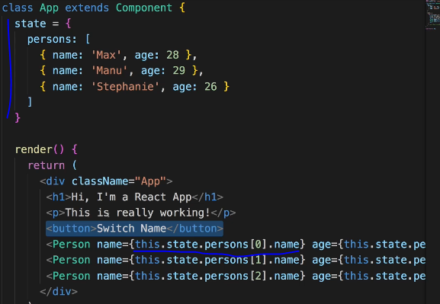

**Props & State**

props and state are CORE concepts of React. Actually, only changes in props and/ or state trigger React to re-render your components and potentially update the DOM in the browser (a detailed look at how React checks whether to really touch the real DOM is provided in section 6).

**Props**

props allow you to pass data from a parent (wrapping) component to a child (embedded) component.

Example:

AllPosts Component:

const posts = () => {

return (

<div>

<Post title="My first Post" />

</div>

);

}

Here, title is the custom property (prop ) set up on the custom Post component. We basically replicate the default HTML attribute behavior we already know (e.g. <input type="text"> informs the browser about how to handle that input).

Post Component:

const post = (props) => {

return (

<div>

<h1>{props.title}</h1>

</div>

);

}

The Post component receives the props argument. You can of course name this argument whatever you want - it's your function definition, React doesn't care! But React will pass one argument to your component function => An object, which contains all properties you set up on <Post ... /> .

{props.title} then dynamically outputs the title property of the props object - which is available since we set the title property inside AllPosts component (see above).

**State**

Whilst props allow you to pass data down the component tree (and hence trigger an UI update), state is used to change the component, well, state from within. Changes to state also trigger an UI update.

Example:

NewPost Component:

class NewPost extends Component { // state can only be accessed in class-based components!

state = {

counter: 1

};

render () { // Needs to be implemented in class-based components! Needs to return some JSX!

return (

<div>{this.state.counter}</div>

);

}

}

Here, the NewPost component contains state . Only class-based components can define and use state . You can of course pass the state down to functional components, but these then can't directly edit it.

state simply is a property of the component class, you have to call it state though - the name is not optional. You can then access it via this.state in your class JSX code (which you return in the required render() method).

Whenever state changes (taught over the next lectures), the component will re-render and reflect the new state. The difference to props is, that this happens within one and the same component - you don't receive new data (props ) from outside!

Button onClick event handler: make sure to use ‘C’ as uppercase in onClick event

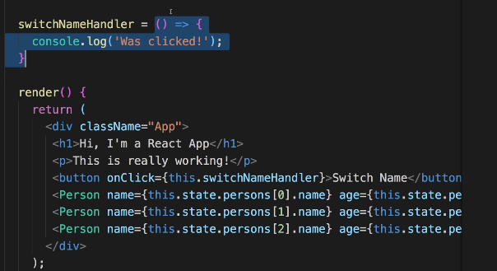

List of supported events:

<https://reactjs.org/docs/events.html#supported-events>

this.setState to update the state of the react DOM. Will only overwrite the requested part, instead of all the state.

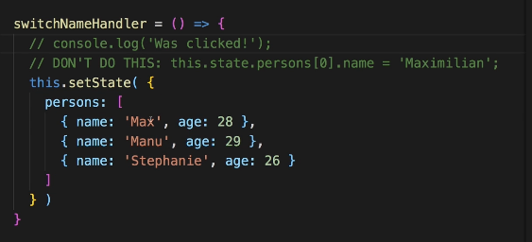

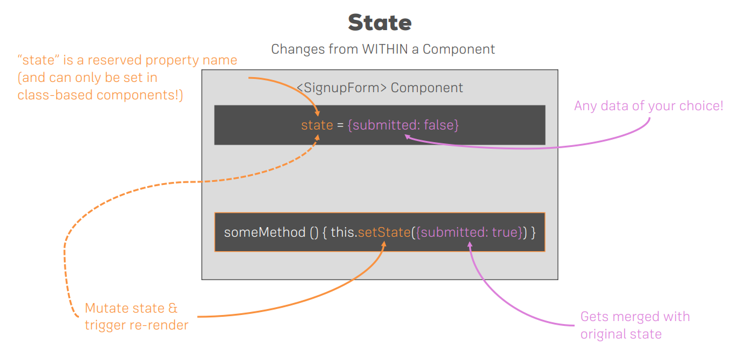

Using React Hooks:

**useState** is the most important recat hooks : Used in place of component in the import header

using functional components instead of class based react components using hooks.

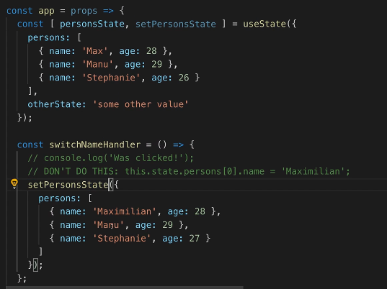

New state will overwrite the old state data, so make sure to manually add the old state data as well

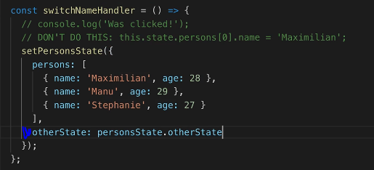

OR create multiple states instead of one single state

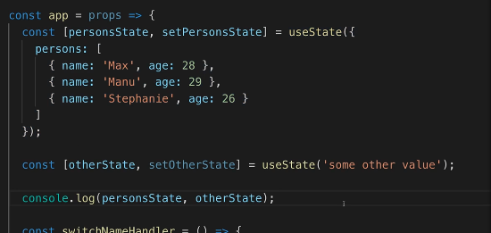

Have as many stateless components and fewer stateful components to avoid issues with maintaining states in multiple places.

Passing method references between components:

In class

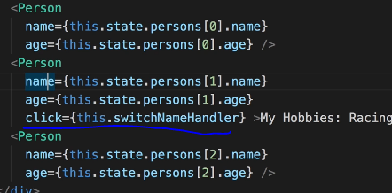

In component:

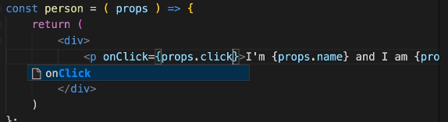

Passing values as arguments to handlers:

Using bind – preferred way

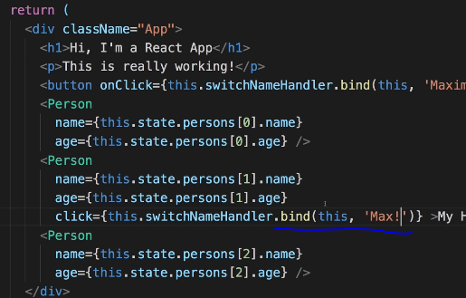

Using arrow function: not much efficient

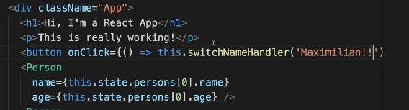

Two way binding

In the class: write a new event handler that accepts the event and can access the value from the event

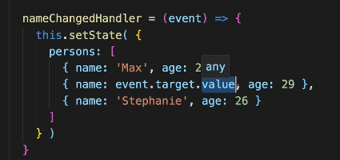

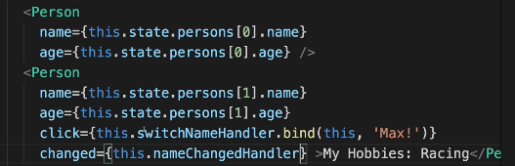

Within the component: accessing the event and also displaying the current value using value attribute. Without change event for a component in the class, the input will be readonly. In the above case, only one Person component has changed event, so only this will be mutable.

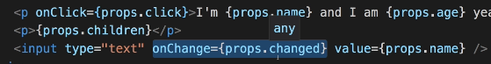

# Render Content Conditionally

Cannot use JavaScript if conditions inside the curly braces within the return block, one way is to just do a conditonal check as below. But this is not a good practice as it can become messy.

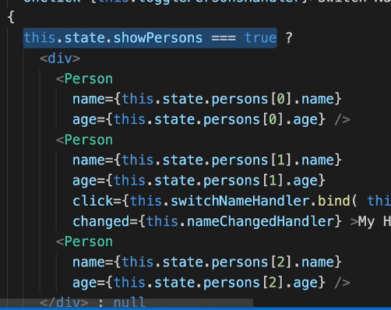

Since all the code inside render block will be executed by react, the ideal way is to create a variable and write a JavaScript condition check within render block before return and use that variable in the return block.

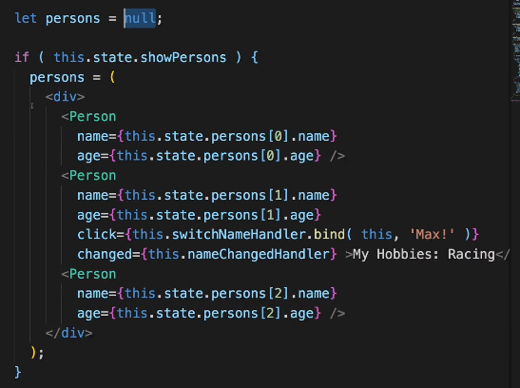

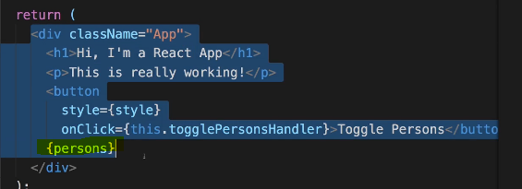

Outputting Lists using map keyword: mapping array

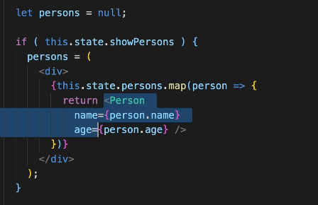

Deleting elements of the array; always update the state immutably without updating the actual object by creating a copy and work on that. Below screen uses, es6 spread operator to copy the elements of the users, delete one element with the index in the argument, and update the users with the new one.

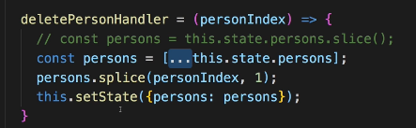

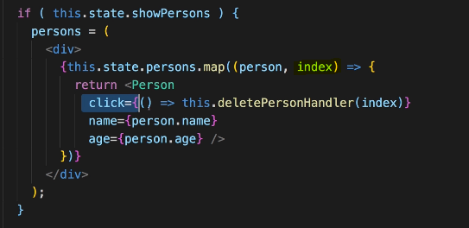

Use React ‘key’ (a unique id, which can be an id of every element in the database, or some unique value) property to efficiently track and rerender individual element of the list. Otherwise, react will just rerender every element which is not efficient when the application has large list of data to render and changes only made in one element.

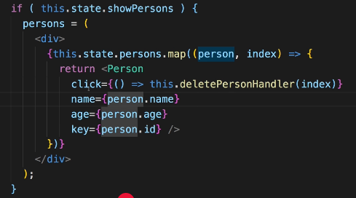

Javascript objects are reference types, so when try to copy the objects, always use spread operator, otherwise u get the pointer to the object. ALWAYS WORK WITH COPY OF OBJECTS.

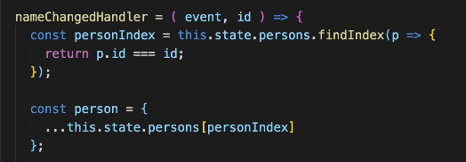

Below screen shows updating the list without mutating the state on ‘name’ change. Always work on the copies, not the actual object.

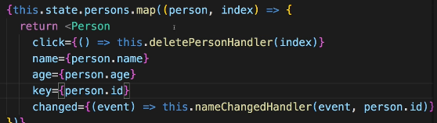

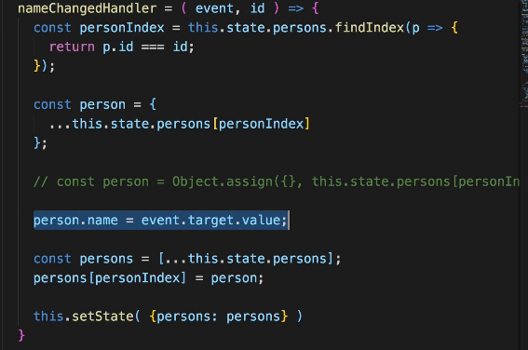

Lists and keys references:

<https://reactjs.org/docs/lists-and-keys.html>

# Styling React components:

Styling can be done in 2 ways:

1. inline styling: writing styles within the components and applied to only that component
2. css files: writing stylesheets and available globally

dynamically change styles:

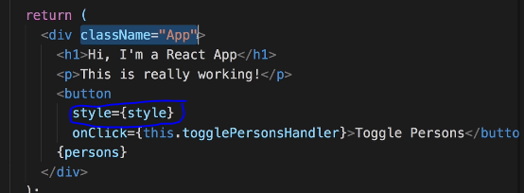

Writing inline style:

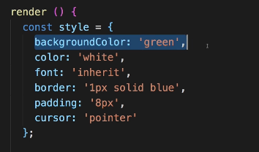

Change style based on a condition: everything is javascript, so can be conditionally handled

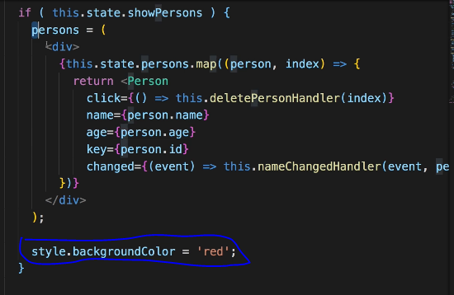

Adding classes dynamically:

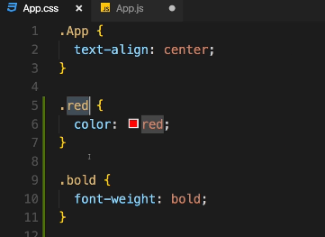

Within component: the array of strings will return as ’red bold’ for <p> tag

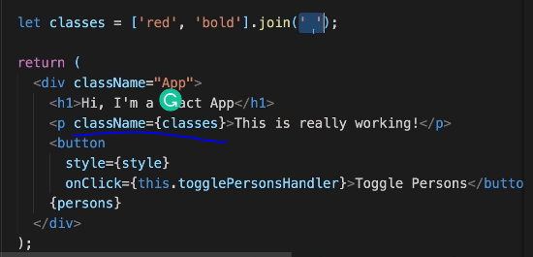

Dynamically apply classes and using join with an empty space to apply all styles in the array.

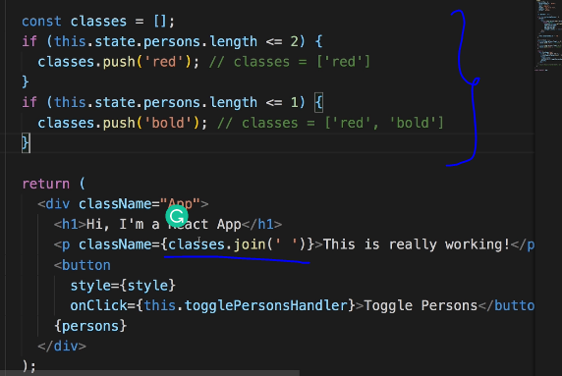

However, the problem with inline styling is cannot apply pseudo selectors, has to be written in css stylesheets. For example if u want to apply hover (button:hover) that cannot be done.

Using third party package Radium to achieve that. **Radium** is a popular package for react which allows to use inline styles with pseudo selectors and media queries

npm install –save radium

After installation, make sure to import Radium in the component.

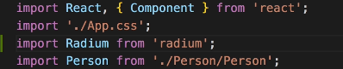

And wrap the component using radium

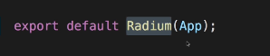

Update in the style

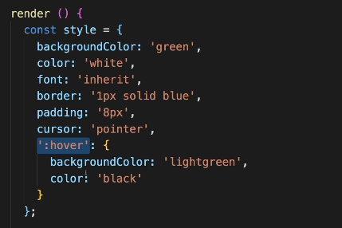

conditional update within the if statement:

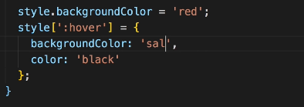

To write media queries using radium, need to import StyleRoot and wrap the whole div with Styleroot:

Writing media query in style variable below and use it in the div. this style will overwrite className which is default css functionality.

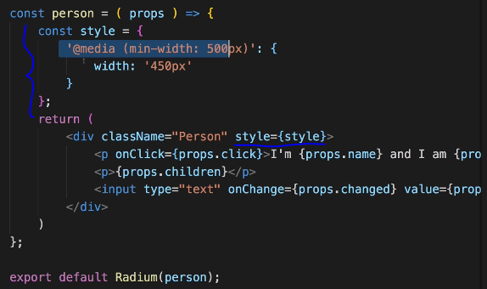

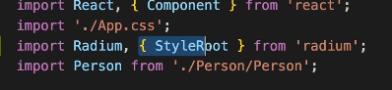

Wrap everything in Styleroot

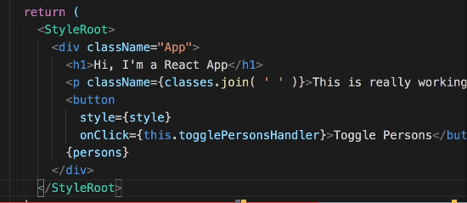

Styled Components Library: other library popular similar to radium

<https://styled-components.com/>

npm install --save styled-components

move all the css between styled components

first import



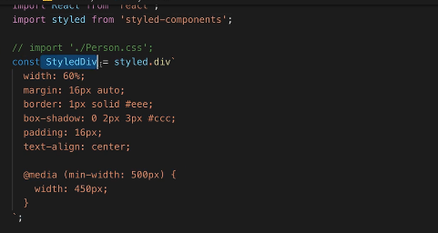

Use this as div

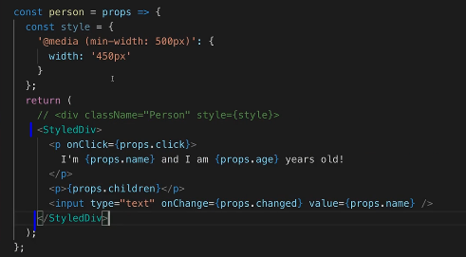

Dynamically changing properties of styledcomponents

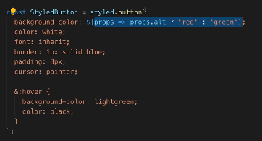

Just add any property (‘alt’ here)

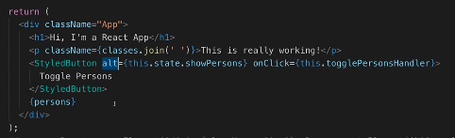

RADIUM AND STYLED COMPONENTS MIGHT MAKE JS CODE BLOATED. INSTEAD USE CSS MODULES TO KEEP JS AND CSS SEPARATE.

To use css modules:

1. UPDATE *.css file name to *.module.css (from person.css to person.module.css)
2. Import the css as : import classes from ‘./person/person.module.css’

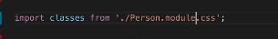

1. Using the property as : <div className={classes.Person}/> (Person is the css in the person.module.css)

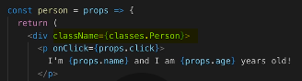

1. To dynamically change the style, just DO AS BELOW

if(this.state.users.length <=2)

classesLst.push(classes.red);

if(this.state.users.length <=1)

classesLst.push(classes.bold);

References for css modules:

<https://github.com/css-modules/css-modules>

# Debugging React Apps

Add React developer tools extension in chrome. Will be part of developer tools.

Use **Error Boundaries** when you need to handle errors in react js. Only use when we know something could fail and can’t control that, not every single time.

Note: Only displays the result of error boundary in deployment server, not in development server.

Usage:

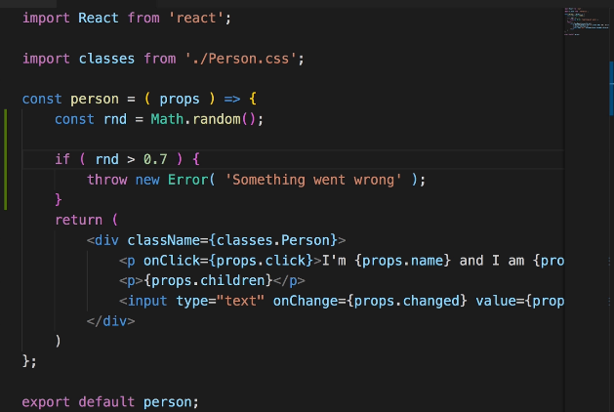

Create a ErrorBoundary class (name can be anything)

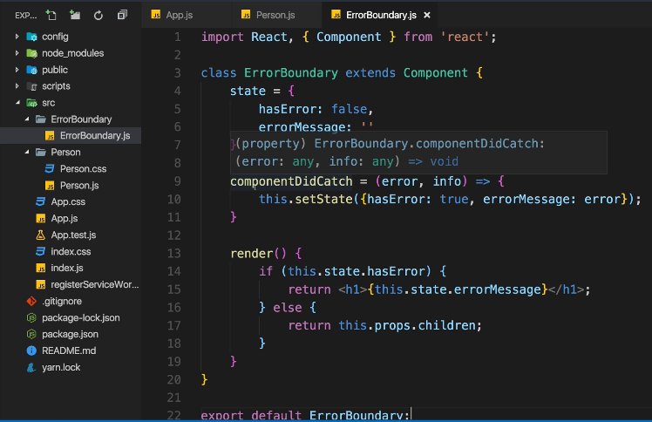

Usage in component:

First import the error boundary on the top of the class component, then wrap the div inside this errorboundary. Make sure to move the key property to top for mapping.

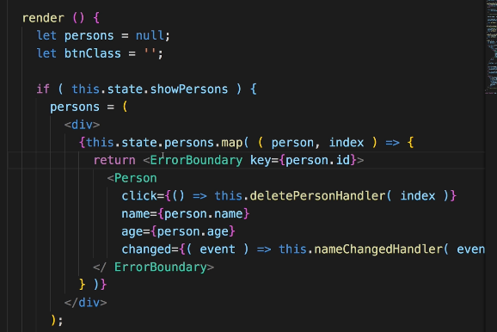

Error boundary Reference:

<https://reactjs.org/docs/error-boundaries.html>

More on Components:

Better project structure:

Move all components under one folder

Move all assets under one folder

Move main class files under Containers folder

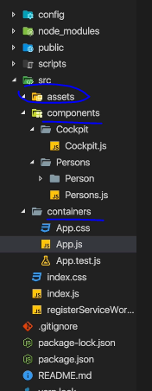

Best practice to have class based components for state management, and functional components for presentation

Have the project structure by outsourcing the granular functionalities.

Example: change below screen to next couple screens:

Screen 1 without any update

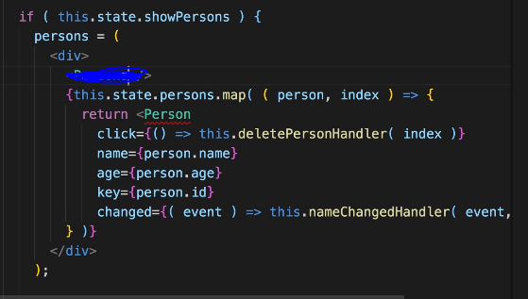

Screens after updating the structure by outsourcing the persons logic

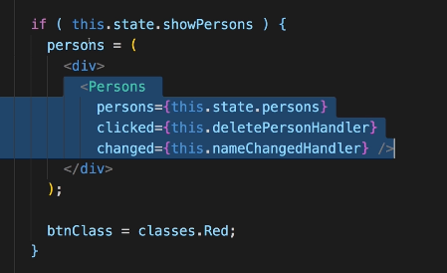

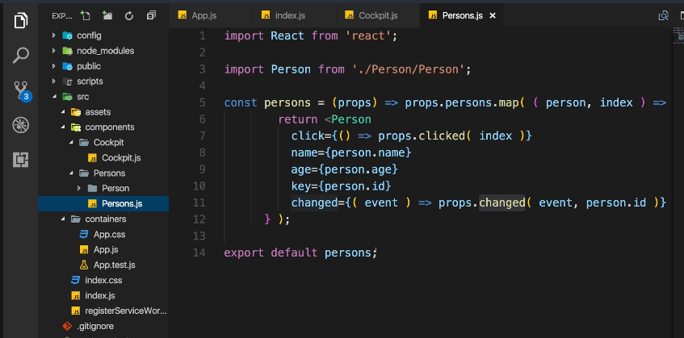

Use as many functional components as possible and maintain lean containers.

Class based vs functional components: access to state in functional components is only available after version of react>16

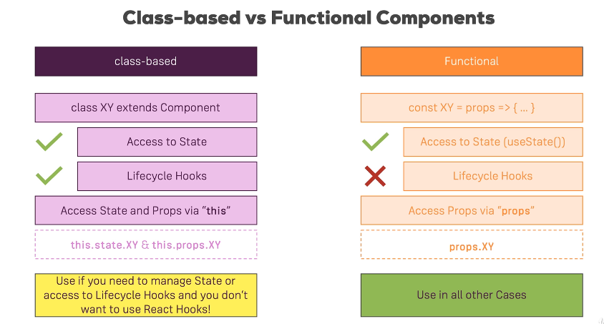

Usage off this.props: Within index.js we can pass properties and access it anywhere within the class as this.props and can be passed to functional components.

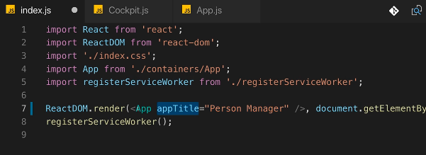

Within class based component:

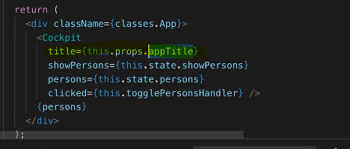

In the functional component:

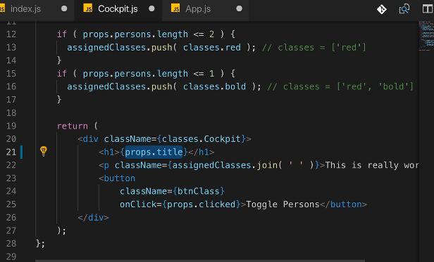

Component life cycle**:**

only available for class based component, while, functional components have an equivalent one

Methods available in any class based component:

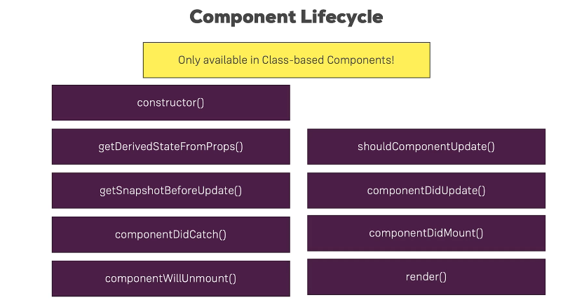

Create lifecycle

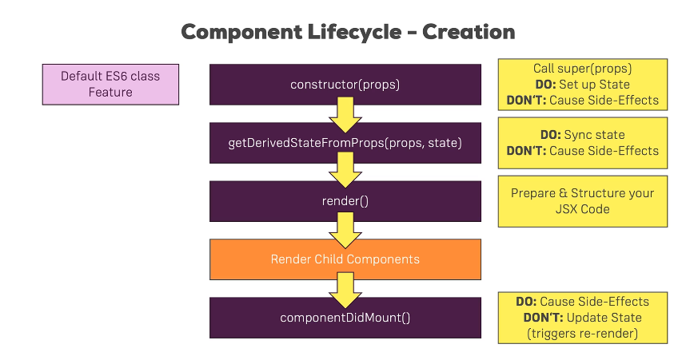

Example of workflow in a classbased component:

1. Adding constructor with props and calling super(props) which will call the parent class constructor and make any necessary initializations. Int this case it will initialize the constructor in the Component class which this class extends

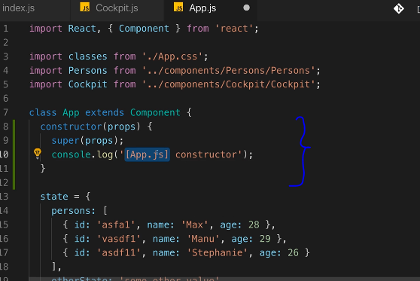

State in the above screen can alaso be initialized within the constructor, with the new version of react>16 state can be initialized outside constructor.

1. Next, getderivedstatefromprops will be executed. Static keyword is important and must for react to execute this properly.

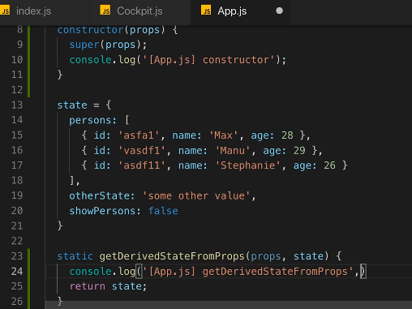

1. Next, render will be executed
2. Now child components will be rendered.
3. Next, componentDidMount will run, which allows us to make http requests

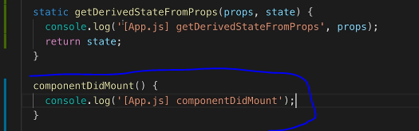

Update lifecycle

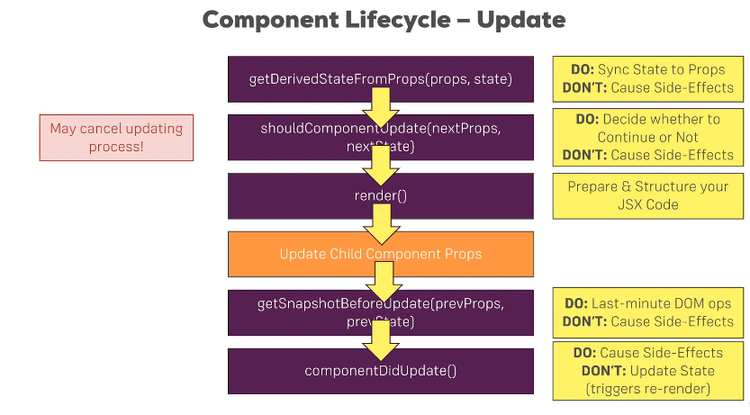

Example:

1. getDerivedStateFromProps will be called

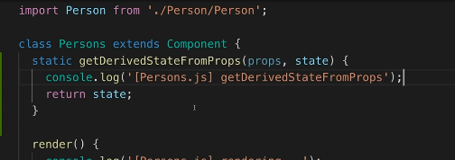

1. ShouldComponentUpdate follows, here conditional based check can be made

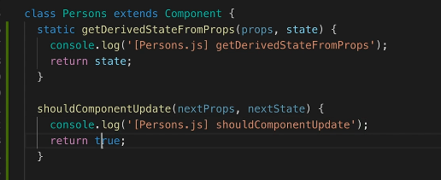

1. Render executes
2. Child components executes
3. getSnapshotbeforeupdate will be executed

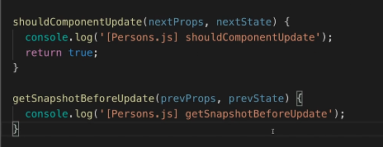

1. followed by Componentdidupdate

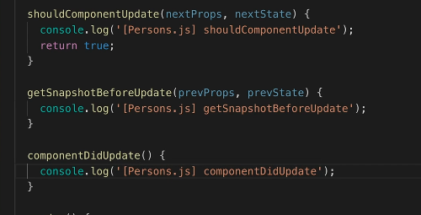

Using useEffect() in functional components

useState and useEffect are two most important hooks in react

Hooks – functions u can add into functional components

useEffect once imported, can be added to a functional component and will run for every render cycle. We can use any number of useEffect in a functional component.

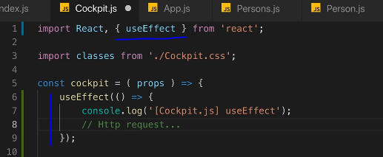

Any http requests can be made here within useEffect, as this executes for every render. It combines ComponentDidMount and ComponentDidUpdate events in class based components.

To only execute useEffect when there is a change in an array we need to explicitly specify a second argument in useEffect as below. The second argument can also be an empty array.

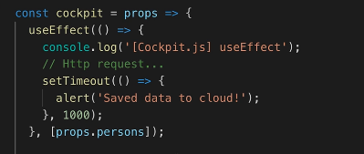

When passing an empty array, the userEffect only runs once on the first render. The empty array tells react that this effect has are no dependencies and so useEffect will not run again.

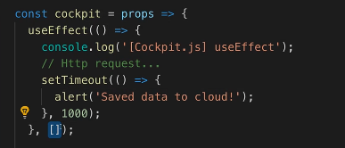

To Clean up or to execute something before component is being removed, then use ComponentWillMount in class based component

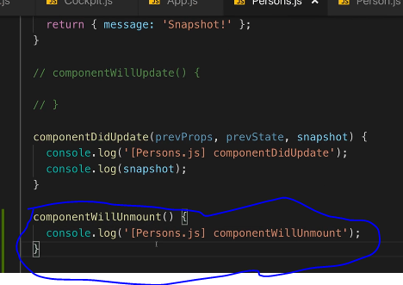

To do the cleanup work in functional component- return in useEffect

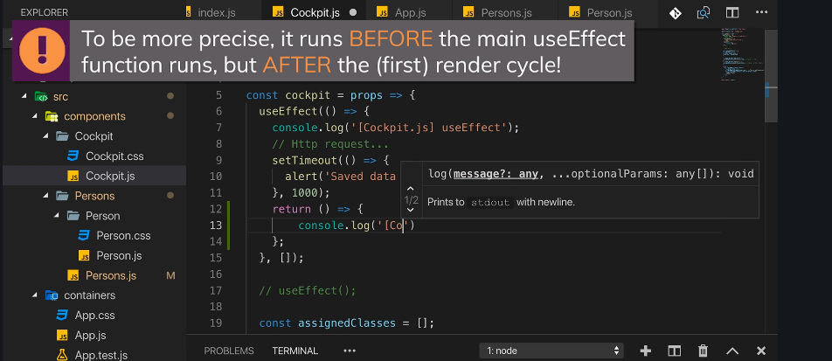

useEffect can be run either when the component gets destroyed (by passing an empty array as the second arguent in useEffect) or when passing without any second argument to useEffect which will run on every update cycle or when passing a valid array which will then useeffect on every time the array changes.

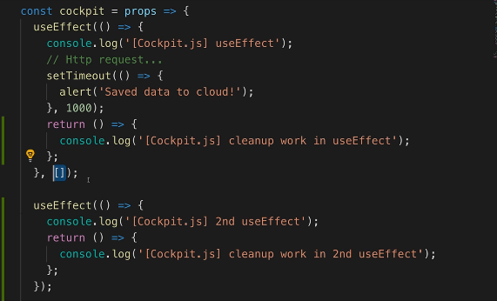

To render any class based component only if there is a change in the object/array then can be done in shouldcomponentupdate as below

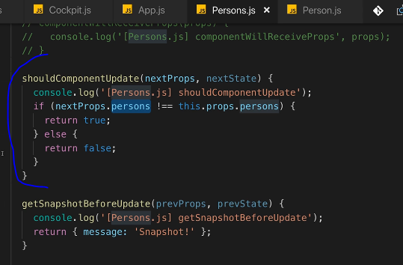

To optimize functional components- use React.memo() (wrap the component )

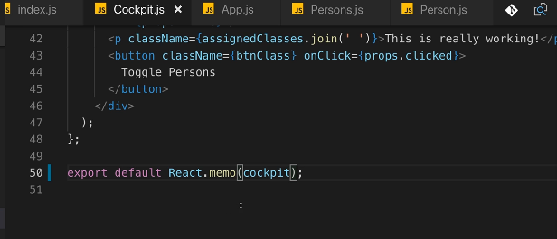

Use PureComponent to check if any prop changed, instead of writing conditions to check for every property changed. It is a normal component that checks for all the prop checks, so instead of using shouldcomponentupdate with all the props changed check, just use purecomponent.

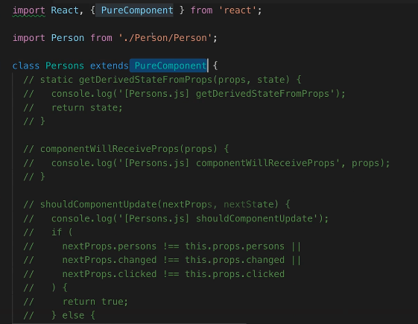

HOW REACT UPDATED THE DOM

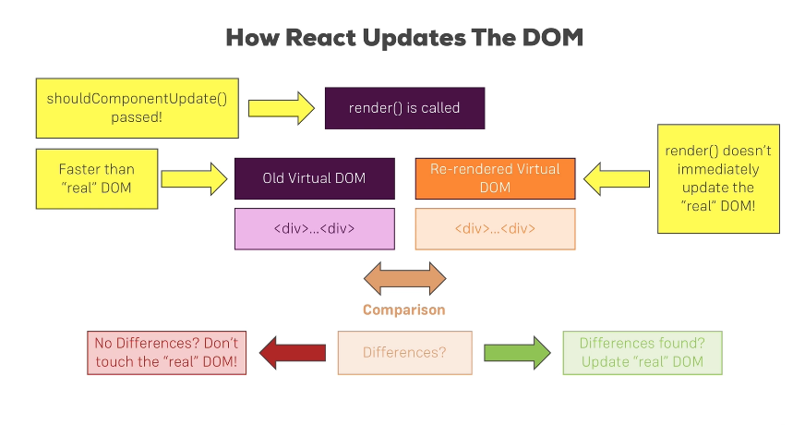

Rendering adjacent JSX elements:

Not possible to render multiple root elements in a jsx file, so one option is to render an ayyar object with multiple elements in it, which is not an optimal way when displaying jsx elemnts. The other way os creating a wrapper and displaying all the children in it.

Hoc-higher order component

Aux- use Aux in mac/linux but in windows use Auxiliary as aux is a reserved word in windows

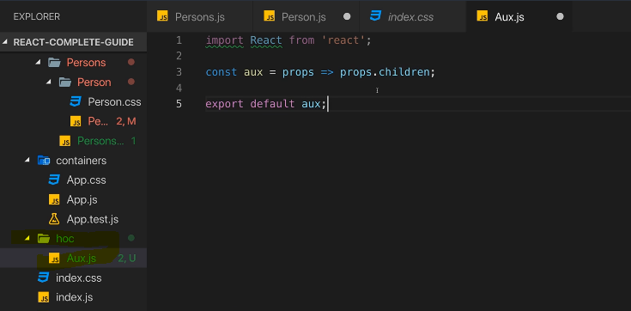

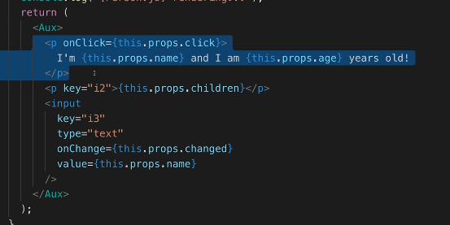

React>16 has in build aux functionality, can be done using React.Fragment as below

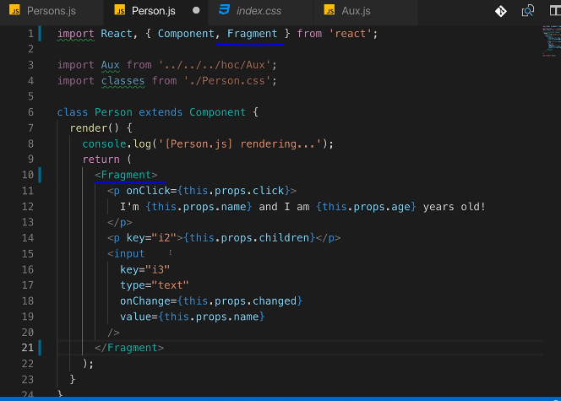

Another example of writing hoc with class:

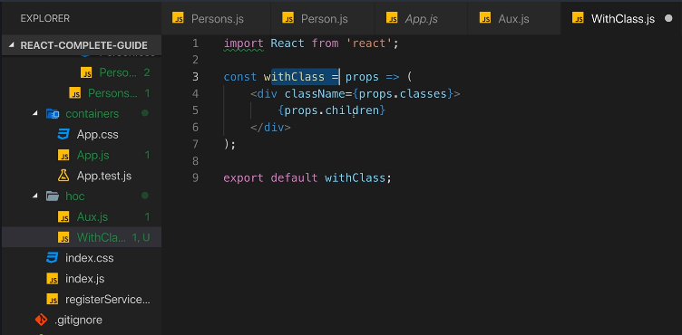

Another form of using hoc: passing functional component and classnames and other parameters as below:

withClass component:

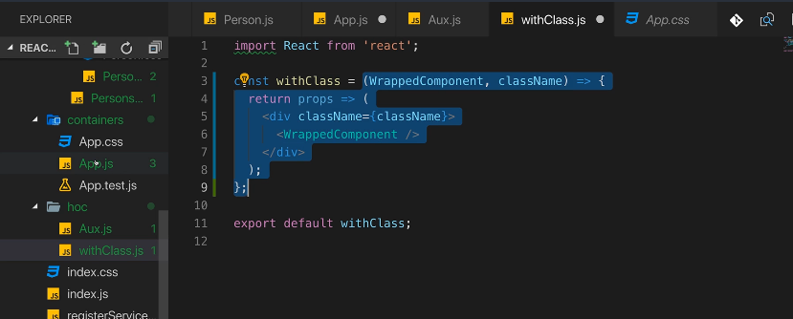

Usage in classbased/ functional component:

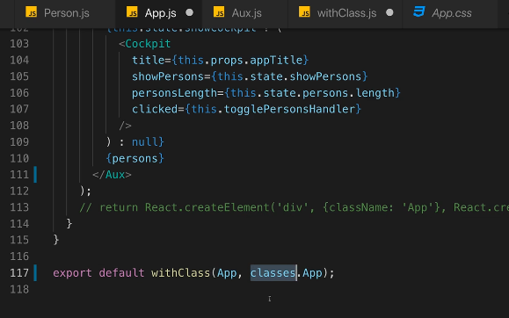

Changing State correctly: better way /good practice to use prev state as below when depending on old state (below example where counter is incremented)

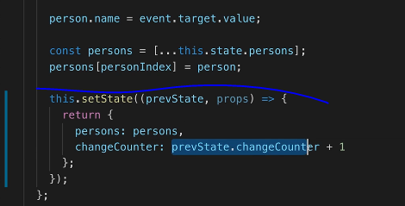

Define prop types for displaying type of the properties and other information: using proptypes package to enforce proper prop types.

Npm install –save prop-types

Usage:

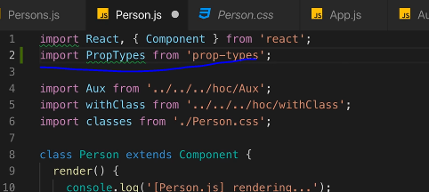

Now add the property types:

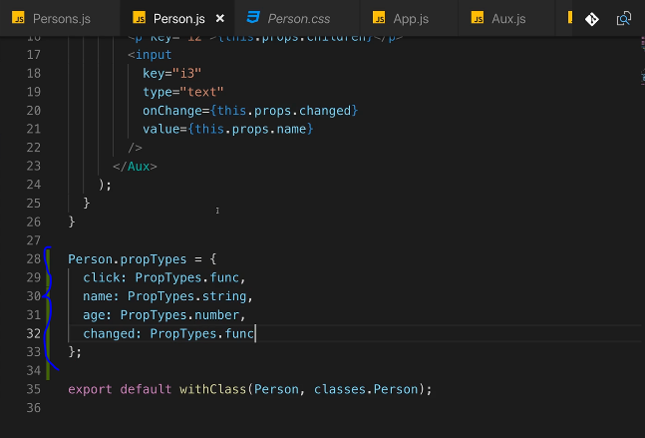

Using Refs: to highlight a specific field or focus a field upon render.

Two ways: one way is without using createRef and one without

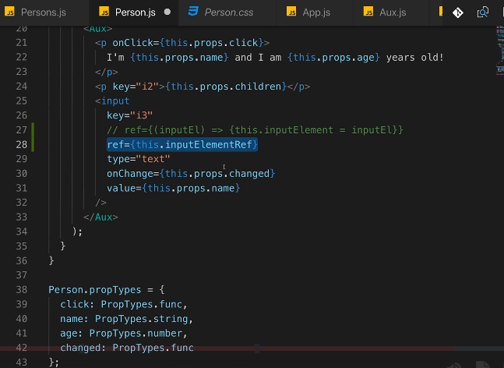

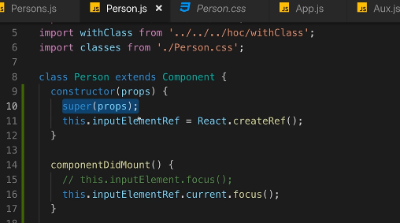

For functional components use react hook useRef as below. Make sure to call the button click after render, that is, in useEffect, which runs after render cycle (see screen 3 below).

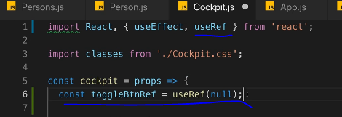

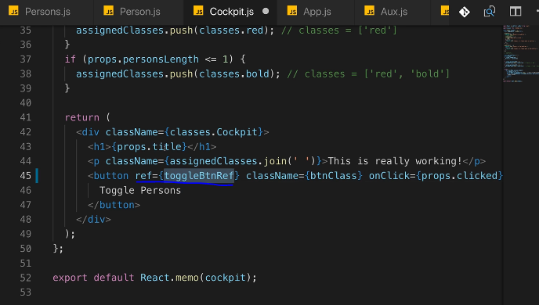

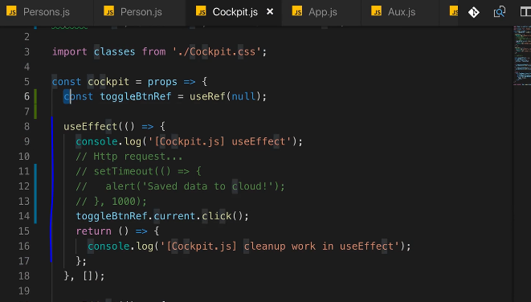

Using the contextAPI: Useful when passing very long chains of data and you don’t want to pass data from component to component to another component and if that data is not needed in between components. Context is the great way of bypassing the components and passing data directly from one component to another component.

useContext() hook in react can be used in functional components vs static contextType in class based component.